# Activity 1.2.1

Consider the following extract of a table of bank customers and answer the questions below:

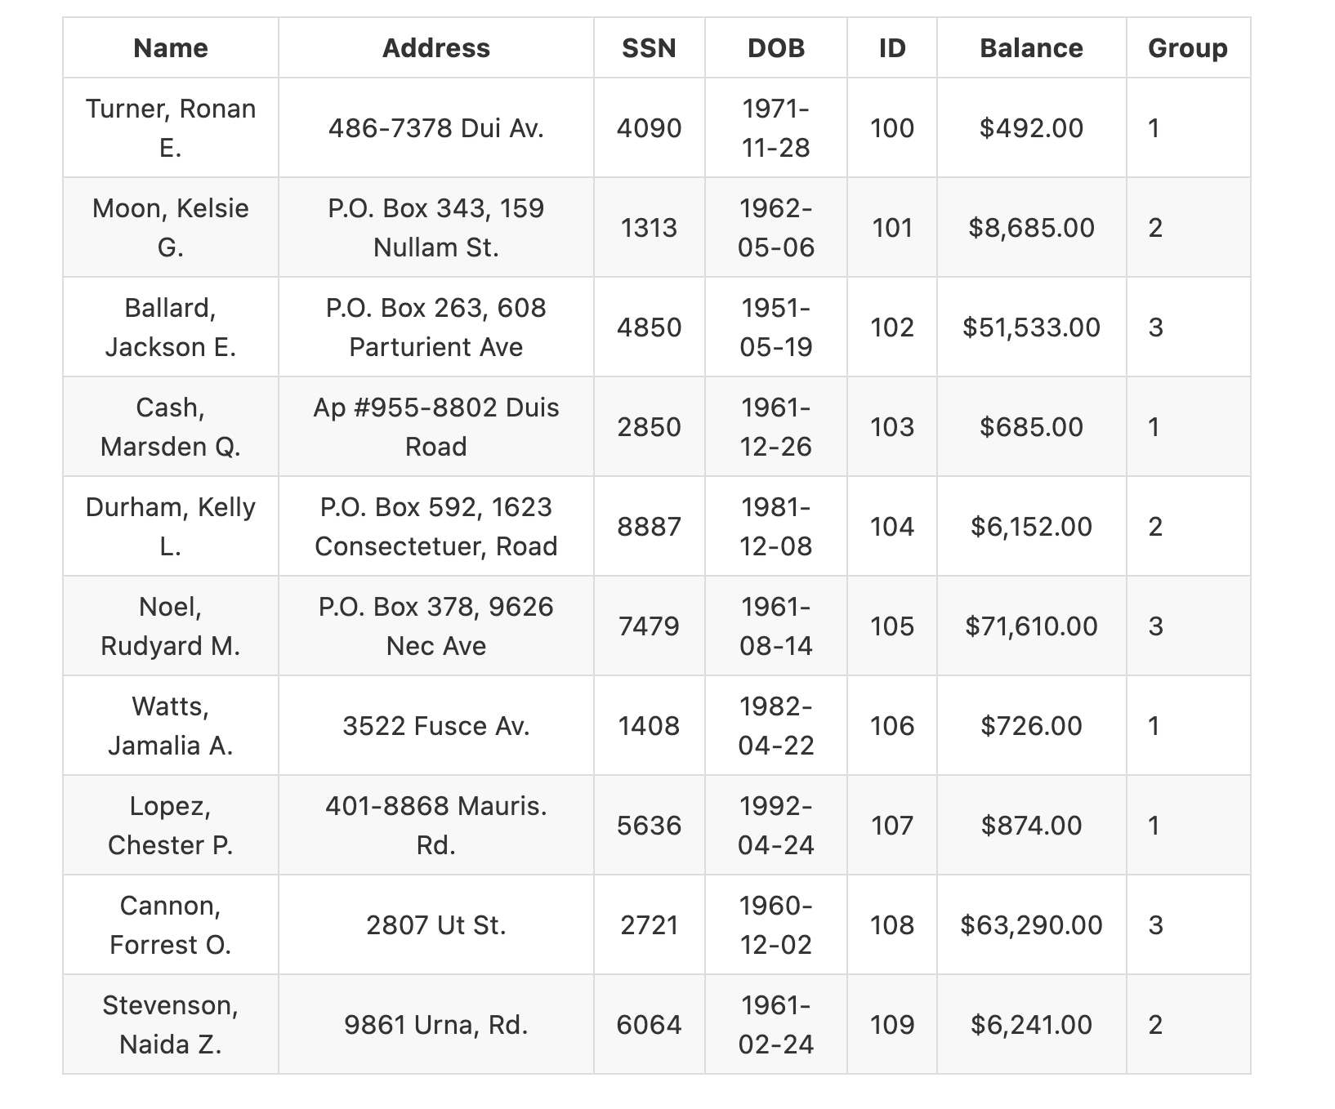

### Questions

* For each column, what is the type of variable?
* Can you obtain the age of each client with the information displayed in the table?